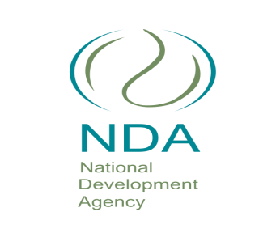
ERRATUM NOTICE

Bid Reference: NDA39/FIN03/19

Bid Description: The identification of premises for office space for the NDA to be occupied over a period of five years in the following areas: Northern Cape (Kimberley, Upington & Postmansburg), North West (Taung & Lichtenburg), Free State (Trompsburg & Qwa-Qwa), Western Cape (Cape town) and Gauteng Johannesburg.

Please be informed that the abovementioned tender has been cancelled.

For further information, please direct enquiries to Ms Khanyi Mngomezulu on 079 126 9278

We apologise for the inconvenience caused

